**OFFICIAL COORDINATION REQUEST FOR**

**NON-ROUTINE OPERATIONS AND MAINTENANCE**

**COORDINATION TITLE -** 21CGR02 Cougar Butterfly Valve Replacement

**COORDINATION DATE -** 30 March 2021

**PROJECT -** Cougar Dam

**RESPONSE DATE -** 13 April 2021

**Description of the problem -** The existing 90-inch diameter butterfly valves and associated equipment controlling water supply to the two main powerhouse generating units (Francis turbines) are becoming increasingly problematic having been originally installed and placed into service in the 1960s. As a result, they are in need of replacement with on-site construction anticipated to occur in CY2023 (Figure 1, Figure 2, Figure 3).

The two main generating units at the Cougar Dam powerhouse use 90-inch diameter butterfly valves to control water supply to the respective turbines (Figure 1, Figure 3). A single intake in the forebay supplies water to a penstock that is then bifurcated into two smaller diameter penstocks, each equipped with a 90-inch butterfly valve, thus allowing water to be supplied to each turbine separately (Figure 2, Figure 3). The use of the butterfly valves provides the project the versatility to take a single unit out of service for operation and maintenance activities while retaining operational capacity of the remaining unit. However, replacement of the butterfly valves requires the placement of a bulkhead at the intake structure in the forebay and dewatering of the entire penstock upstream of the butterfly valves, and the scroll case which is immediately downstream of the butterfly valves. This results in both units being out of service simultaneously and thereby forcing all water flow through the regulating outlets (ROs) for the duration of butterfly valve replacement activities.

The manufacturing and preliminary shop testing of the new 90-inch diameter butterfly valves and the associated control systems will occur at the Contractor’s facility. Upon successful factory acceptance testing, the valves and ancillary systems will be transported to site, installed, inspected, and tested prior to returning the powerhouse to normal service. Removal of the existing butterfly valves and ancillary systems will not be permitted until the Government provides conditional approval of all shop testing and all Contractor furnished new equipment is delivered on-site and ready for installation.

Onsite installation is anticipated to take 12-16 weeks and will require both units to be offline with the penstock intake bulkhead in place. Lessons learned on a previous project of similar scope and recent market research has demonstrated that at least 12 weeks is necessary to install, test, adjust, and commission the two new butterfly valves and associated systems. While a 12-week outage is currently anticipated as being necessary, it is suggested that a continuous outage window of 16 weeks be identified in the event that construction takes longer than anticipated due to weather, holidays, and/or unforeseen issues.

It is preferential to conduct this replacement of both butterfly valves at the same time thus reducing overall outage window(s) and duration(s) while minimizing overall project costs. While refurbishment of the existing butterfly valves was initially explored, it was determined that full replacement is the more cost-effective alternative with shorter construction outage periods and lower overall project risks.

**Type of outage/change required** - The Cougar Dam powerhouse will need to be offline for 12-16 weeks with the intake penstock bulkhead installed resulting in all water passing through the regulating outlets (ROs).

**Impact on facility operation -** Replacement of the butterfly valves requires the placement of a bulkhead and dewatering of the penstock which simultaneously takes both units out of service and thereby resulting in all water flow going through the regulating outlets (ROs). The spillway would continue to be operated only in emergency scenarios.

* The full powerhouse outage will result in no water flow through the powerhouse during the full outage period.
* The Adult Fish Collection Facility (AFCF) can continue to operate as it draws water from the tailrace via pumps, but there will be no powerhouse channel attraction flows during the outage other than the flows from the AFCF itself.
* No downstream fish passage will occur through the powerhouse with the units offline and therefore if rotary screw trap monitoring is occurring at the time, only RO channel monitoring would occur.
* ODFW half-duplex PIT tag detectors can continue to operate in both the powerhouse and RO channels without impact.

**Length of time for repairs -** The Cougar Dam powerhouse will need to be offline for 12-16 continuous weeks. A period of up to 16 continuous weeks for the powerhouse outage is necessary in the event that issues with removal of existing valves, installation and commissioning of the new butterfly valves arise.

**Dates of impacts/repairs -** The Corps proposes to take the Cougar Dam powerhouse offline from 01 February 2023 to 31 May 2023 for removal of existing equipment, installation of new penstock butterfly valves and associated systems. The powerhouse will be returned to service earlier if feasible.

**Expected impacts on fish**

Typically, in accordance with the WFOP, full powerhouse outages are scheduled to occur in April and May to minimize fish impacts. Powerhouse outages are generally restricted during the Nov 01 to March 31 time period in order to prevent high levels of TDG that can have negative impacts on sac fry.

Increased TDG from RO spill may impact spring Chinook sac fry downriver in February, however this risk decreases into March/April as juvenile salmonids begin migrating downstream.

The AFCF is typically offline mid-October through March and spring Chinook collections are usually low through May. When the AFCF is operating beginning in April, attraction flows in the powerhouse channel will be limited to only flows coming from the AFCF itself. Commissioning of the new systems will occur towards the end of construction, which will provide limited attraction flows to the AFCF.

Upstream migrants may be falsely attracted to the RO channel and if the AFCF is operating, fish collections are expected to be low until powerhouse flows are restored.

Bull trout often enter the ACFC when it is first brought online in March/April (typical range 4-20 individuals) and then only periodically thereafter. Any bulltrout collected will continue to be handled in accordance with established procedures.

**Comments from agencies**

**Final results**

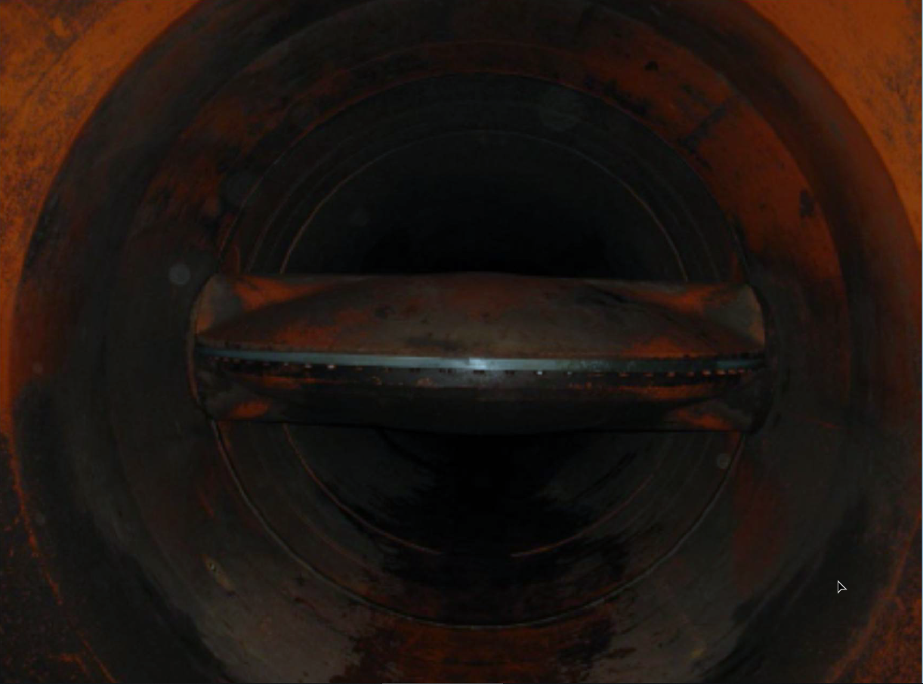

Figure 1 - Interior view of Cougar Dam penstock and 90-inch diameter butterfly valve in the open position.

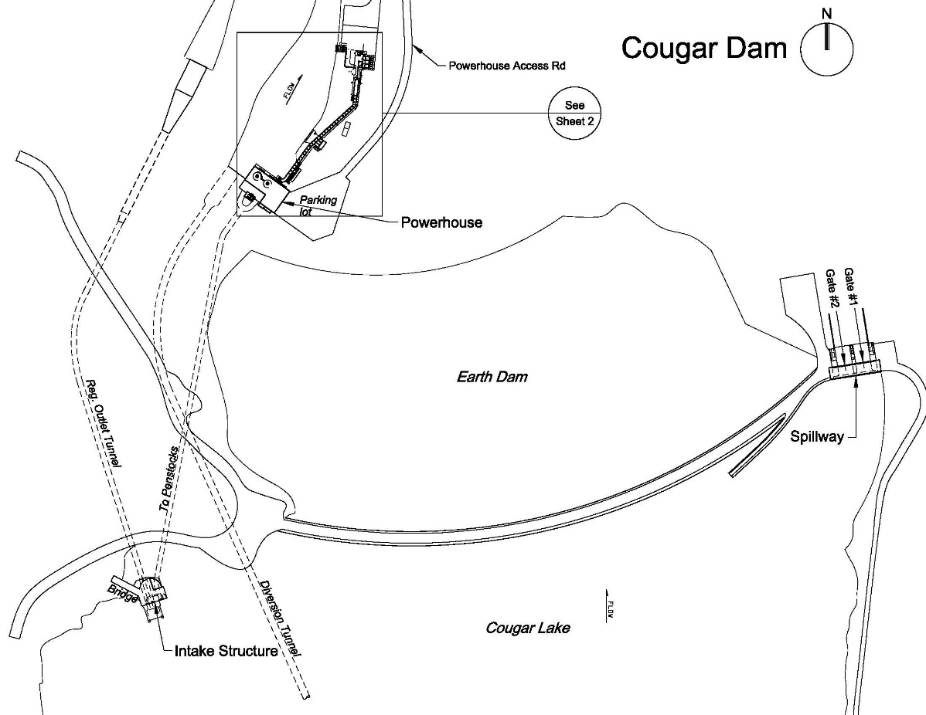

Figure 2 - Cougar Dam Schematic (taken from McKenzie Subbasin Fish Operations Plan - Figure MCK 2).

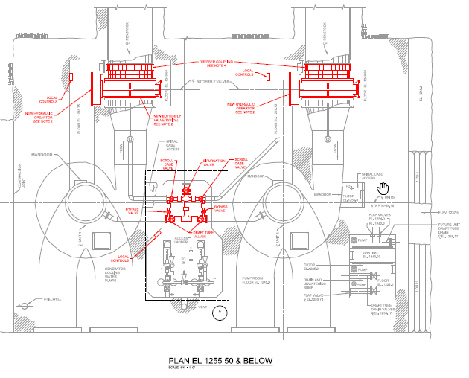

Figure 3 - Schematic of Cougar Dam turbine penstocks including 90-inch diameter butterfly valves and associated control systems. Mechanical items being replaced are drawn in red.